11/26/23

Griffin Rzonca

Testing New Board

* Tried soldering a new audio board with just ESP32 peripherals and 3.3V converter to see if the issue was caused by soldering or other component interactions
* First goal: capture waveforms and compare

Recall:

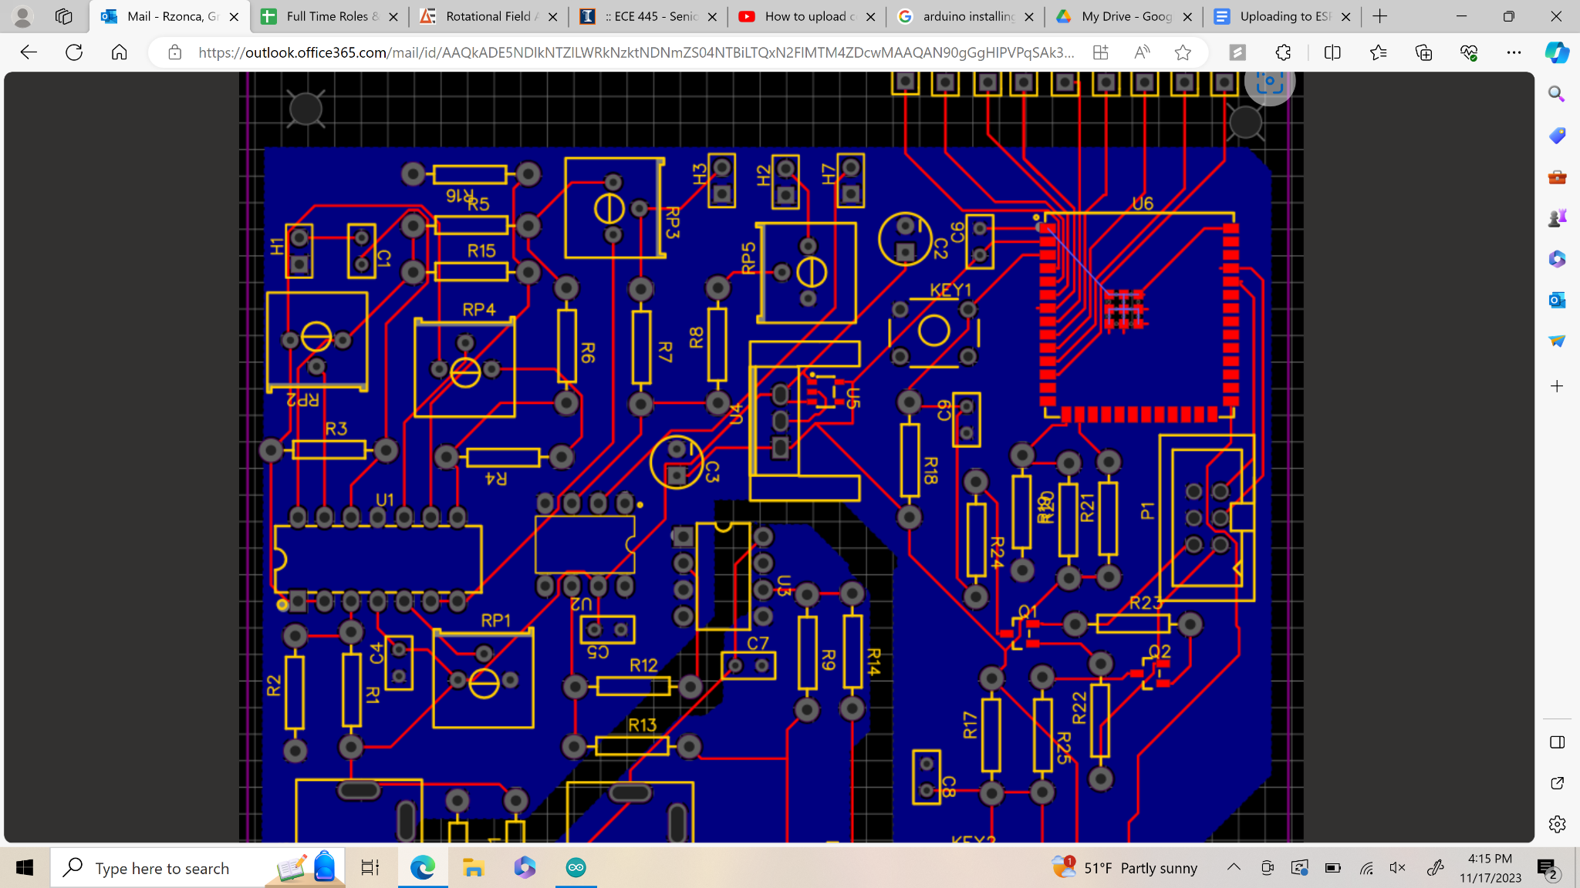

Pinout:

| 6 | 5 - RX of ESP32 |
| --- | --- |
| 4 | 3 - TX of EP32 |
| 2 - DTR | 1 - RTS |

Waveforms:

USB/UART Output when uploading but not connected to anything - Do they vary during upload?

RTS: Yes

DTR: Yes

TX: Yes  
RX: No (but it shouldn’t anyway)

* 3.3V regulator on new board is working, ESP32 has 3.3V in its 3.3V port
* And, the grounds are shared with no inherent voltage difference between them like last time… very encouraging

Inputs on ESP32 - Do they vary during upload?

EN (pin 3): Yes

IO0 (pin 27): No

TXD0 (pin 37): Yes, const high freq. Sq. wave signal, same as last time

RXD0 (pin 36): No

Waveforms:

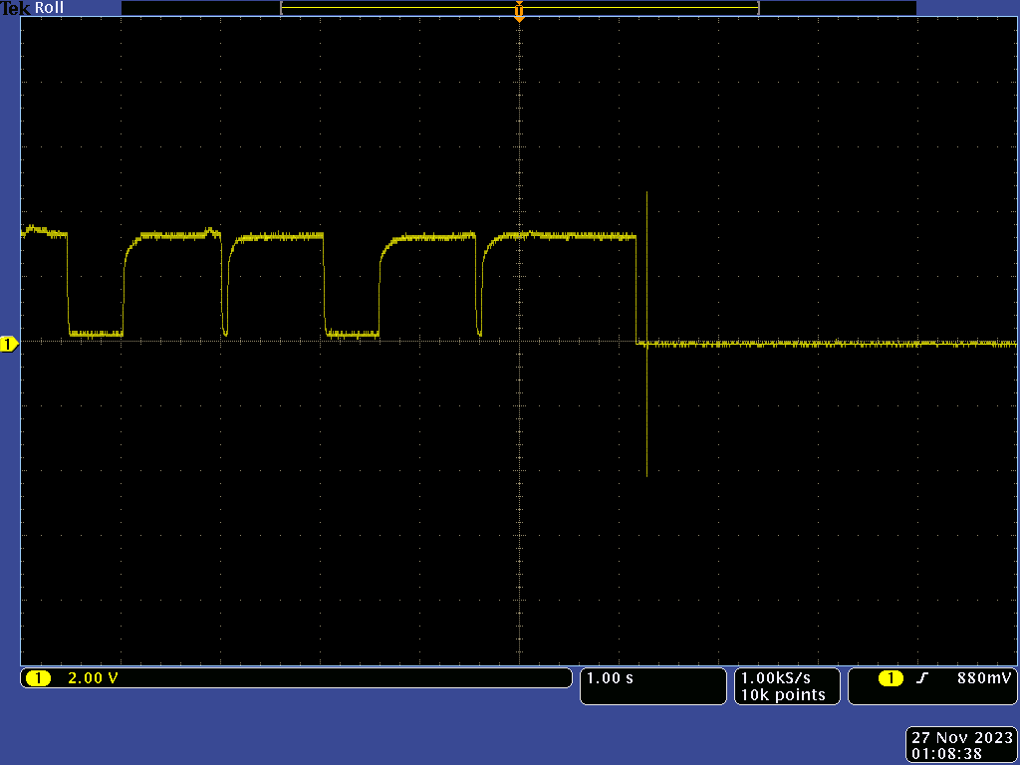

Fig. 1 Above: EN during upload

Fig. 2 Above: IO0 during upload

Fig. 3 Above: TXD0 during upload

Fig. 4 Above: RXD0 during upload

Prev Data from old board: [[[

EN (pin 3): Yes

IO0 (pin 27): Yes, but doesn’t reach all the way to 0

TXD0 (pin 37): Yes, same wave as RX port of the USB/UART in Figure 1; const. High freq. Before upload, but has pulses during upload

RXD0 (pin 36): Yes

]]]

* Upload still isn’t working, going to take a pause on testing this and make sure that worst case scenario we can still just connect the dev kit and it’ll work
  + Code and freq. Generator already work, just making sure then can operate when connected to the old board
* Went back to old board, got upload working but could not get the code to execute for some reason
* Had to remove resistors R19-21
* Used buttons instead of programming circuit
* Code uploads! But even simple serial print programs will not do anything
* Otherwise, entire project works! Just have to use dev kit